Key Concepts
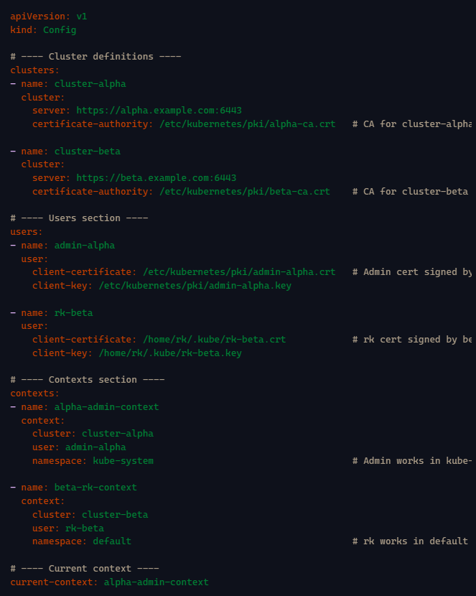
kubeconfig File
  - Acts as a configuration file to store server details, user credentials, and contexts.
  - Used internally by kubectl commands to authenticate and authorize user requests to the Kubernetes API server.
Contains:
    - apiVersion and kind (standard Kubernetes manifest metadata).
    - An array of clusters (multiple cluster configurations can be included).
    - An array of users with their authentication credentials (client certificates, keys).
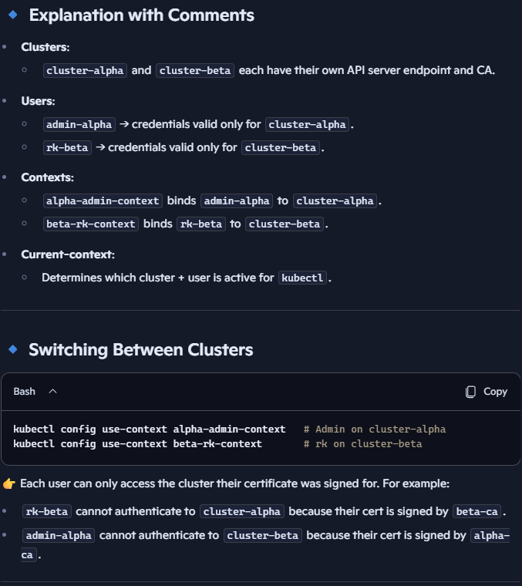
    - An array of contexts. Contexts bind a user + cluster + namespace together. Switching contexts changes which cluster you talk to and which credentials are used.
    - Default kubeconfig is located at $HOME/.kube/config.
  - You can specify a custom kubeconfig using kubectl --kubeconfig <file-path>.
  - Certificate data (client certificate and key) may be embedded or referenced as file paths.
  - By default, kubeconfig is stored in your local workstation at: ~/.kube/config
  - This file is client-side only. It doesn’t live inside the cluster or on the nodes. It’s essentially your personal credential + connection map to one or more clusters. The clusters themselves don’t share kubeconfig — only your client does.
  - The cert/key paths (for CA/users) mentioned in kube config yaml are local filesystem paths on the machine where you run kubectl. They are not stored inside Kubernetes itself.
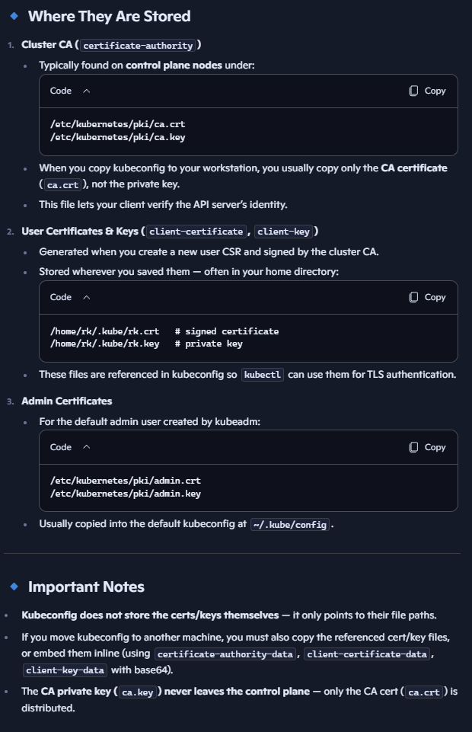
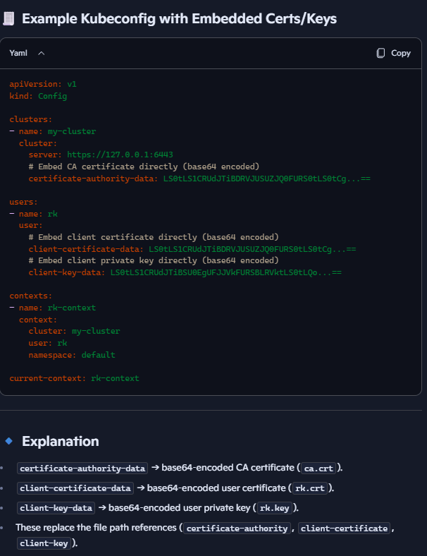

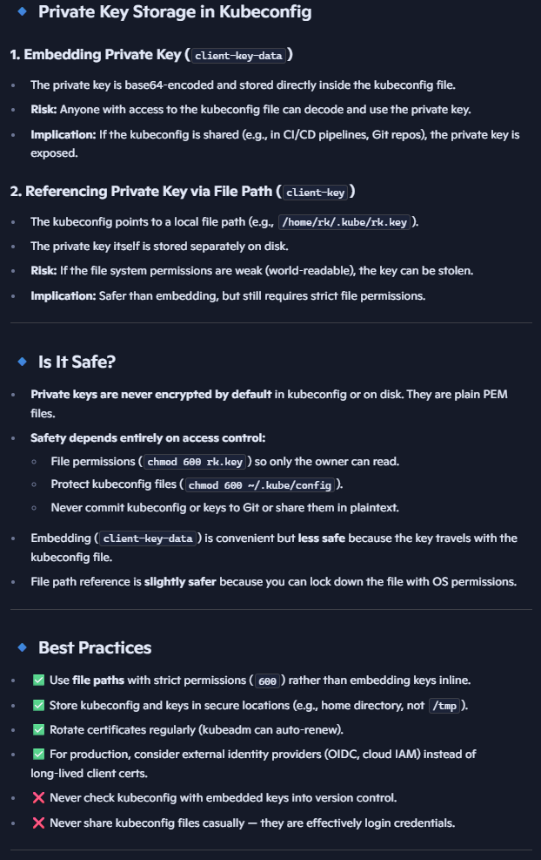

How Authentication Works with Kubeconfig
  - kubectl reads kubeconfig → picks the current context.
  - Context defines cluster + user.
  - Cluster → API server endpoint + CA cert (to verify server).
  - User → credentials (client cert/key, token, or OIDC).
  - kubectl sends request → API server verifies:
TLS handshake (server proves identity with CA-signed cert).
  - Client proves identity (certificate, token, or other method).
  - If authentication succeeds → request moves to authorization.
Authorization: Once authenticated, Kubernetes checks RBAC (or other modes). Authorization determines whether a user has permission to perform certain actions (e.g., get pods, create pods). Kubernetes supports multiple authorization modes:
- ABAC (Attribute-Based Access Control): Legacy mode
      - Permissions are specified in a policy file (JSON) linked to API server config.
      - Requires API server restart on changes, making it less practical for dynamic environments.
- RBAC (Role-Based Access Control): Most common
      - Defines Role or ClusterRole objects with specific permissions, bound to users/groups via RoleBinding or ClusterRoleBinding. Example: allow “rk” to list Pods in default namespace.
      - More flexible and widely used; does not require API server restart on changes.
- Node Authorization:
      - Special mode for kubelets. Used by nodes to interact with each other, and with API server.
- Webhook Authorization:
      - Delegates authorization decisions to 3rd party external systems like Open Policy Agent (OPA).
      - Requests sent to the webhook service, which grants or denies access.
  - The API server can use multiple authorization modes simultaneously, processed in the order configured.
  - If no authorization mode is specified, the default mode is AlwaysAllow, which grants all authenticated users full access (not recommended for production).

Admission Control: after authorization, admission controllers can still modify or reject requests (e.g., enforcing quotas, policies).

API Server Configuration
  - The API server is configured through a static pod manifest located at /etc/kubernetes/manifests/kube-apiserver.yaml.
  - This manifest file includes flags for authorization modes (--authorization-mode=node,RBAC).
  - Certificate files and client CA files are referenced here, located by default in /etc/kubernetes/pki.
  - Multiple certificates are maintained because the API server acts both as a server (for kubectl, controller manager, scheduler) and as a client (when interacting with etcd and kubelets).
- Certificates and Keys
  - Certificates are essential for secure communication and authentication between components.
  - The directory /etc/kubernetes/pki holds all key and certificate files.
  - Separate key pairs may be used for different communication channels (e.g., API server <-> etcd vs API server <-> kubelet).

Kubernetes Authorization Modes Table
Authorization Mode | Description | Use Case | Key Characteristics
ABAC | Attribute-based policies defined in a static file | Simple static environments | Requires API server restart after policy changes
RBAC | Defines roles and binds them to users/groups | Most common for flexible permission management | Dynamic updates without API server restart
Node Authorization | Controls node-to-API server communication | Securing node interactions | Used internally for kubelet and API server auth
Webhook | Delegates authorization decisions to an external service (e.g., Open Policy Agent) | Complex/custom policies | Externalizes policy management, supports dynamic rules

Summary of Workflow
- When a user runs a kubectl command:
  - kubectl reads the kubeconfig file to gather cluster API server info and user credentials.
  - The API server authenticates the user.
  - Then, authorization modes (node, RBAC, etc.) are checked in order to determine if the action is permitted.
  - Permissions are granted or denied accordingly.

